CHANGE OF ACCESS ON RECORDED PLAT
PROCEDURE

The following procedure has been approved by the City’s Traffic Engineering Department, County Engineering Department and the Tulsa Metropolitan Area Planning Commission (TMAPC) for changes of access on recorded plats.
- Applicant should review the proposed change with appropriate engineer, or their designated representative, prior to preparing the forms. For locations within City of Tulsa, contact the City of Tulsa Traffic Engineer; otherwise, contact the Tulsa County Engineer. Contact information for either engineer can be obtained through the Tulsa Planning Office.
- If the change is agreeable with both the applicant and the engineer, then follow the procedure below.
- Step-by-step procedure:
  - Fill out the Application Form, including legal description and address.
  - Prepare a small and precise Exhibit to accompany the Change of Access form. (This should not be larger than 8 ½" x 14".)
  - Obtain the plat number from the County Clerk's office.
  - Sign and notarize, taking care to use proper notary (Individual or Corporate).
  - Submit the forms to the appropriate engineer for review and signature.
  - Bring signed Application Form, Change of Access Form, with Exhibit to Tulsa Planning Office, Tulsa City Hall, 175 E. 2nd St, Suite 480, Tulsa, OK 74103.
  - Pay $100.00 filing fee, made payable to City of Tulsa.
  - Staff will place item on an agenda for approval and signature by TMAPC.
  - Staff will return original to applicant who should take the instrument to County Clerk to file of record.
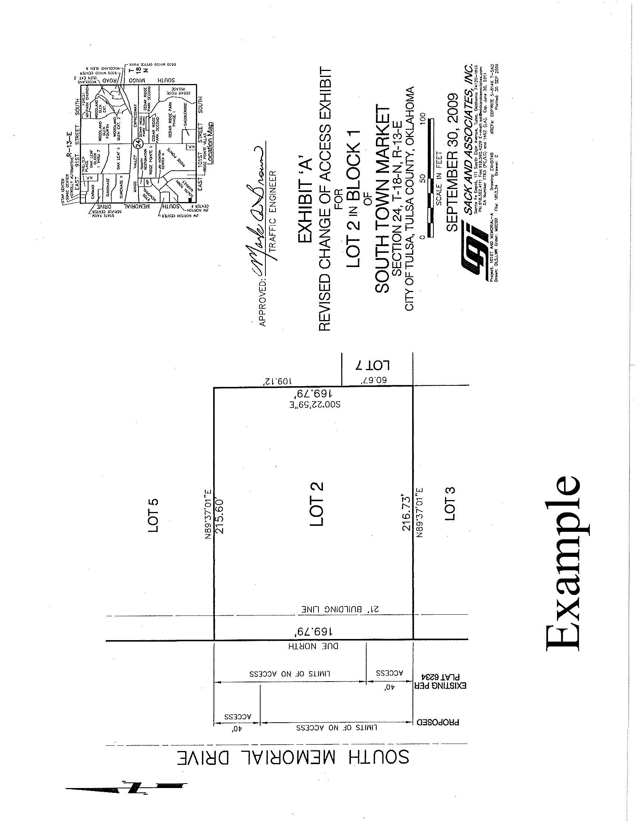

TULSA METROPOLITAN AREA PLANNING COMMISSION
175 East 2nd St, Suite 480 - Tulsa, OK 74103 - (918) 596-7526 - tulsaplanning.org Submit applications to planning@cityoftulsa.org

CHANGE OF ACCESS

APPLICATION INFORMATION

RECEIVED BY:_____________ DATE FILED: ___________________ __TMAPC DATE: ______________________________________________
APPROVED PLAT WAIVER REQUIREMENT: YES:______ NO:______

REFERENCE CASES
PLAT NAME:
ZONING/PUD/CO CASE: |  | BOARD OF ADJUSTMENT CASE:
TMAPC DATE: |  | BOA DATE:

SUBJECT PROPERTY INFORMATION

ADDRESS OR DESCRIPTIVE LOCATION:
LEGAL DESCRIPTION:

PRESENT USE: _PRESENT ZONING: ____________PROPOSED ZONING: CD:

SUBMITTAL REQUIREMENTS
This application must be accompanied by a copy of the applicant's proposal, including the original and two (2) copies of 'Change of Access' form, signed and notarized by owner(s) with accompanying map, no larger than 8½" x 14" with the engineer's approval shown on maps and forms.

APPLICANT INFORMATION | PROPERTY OWNER INFORMATION
NAME | NAME
ADDRESS | ADDRESS
CITY, ST, ZIP | CITY, ST, ZIP
DAYTIME PHONE | DAYTIME PHONE
EMAIL | EMAIL
I, THE UNDERSIGNED APPLICANT, CERTIFY THAT THE INFORMATION ON THIS APPLICATION IS TRUE AND CORRECT.
SIGNATURE & DATE:

DOES OWNER CONSENT TO THIS APPLICATION? [ ] Y [ ] N. WHAT IS APPLICANT’S RELATIONSHIP TO OWNER?

APPLICATION FEES (Make checks payable to City of Tulsa)
TOTAL DUE: | $100.00 | RECEIPT NUMBER:
Application fees in whole or part will not be refunded after STAFF REVIEW has been COMPLETED.

PROCESS TRACKING/ DISPOSITION
ENGINEERING REVIEW: |  | ORIGINAL TO APPLICANT:
TMAPC ACTION: |  | COPY TO HOUSE NUMBERING:
TMAPC DATE/VOTE: |  | COPY TO FILE:

CHANGE OF AND CONSENT TO
AREAS OF ACCESS AS SHOWN ON RECORDED PLAT

WHEREAS, ___________________________________________________ are the owners of ______________________________________________________, in the city and/or county of Tulsa, Oklahoma, according to the recorded plat thereof; and

WHEREAS, said owners desire to change the access points from _________ _______________________________________ to the above described property and,

WHEREAS, such change requires approval of the Tulsa Metropolitan Area Planning Commission; and

WHEREAS, the Tulsa Metropolitan Area Planning Commission may approve such change of access with a favorable recommendation by the designated Engineer of the City of Tulsa, Oklahoma.

NOW THEREFORE, the undersigned owners of the above named property in the City of Tulsa, Oklahoma according to the recorded plat thereof, does hereby change the access point(s) from its (their) present location as shown on the above named plat as recorded in the office of the County Clerk of Tulsa County, Oklahoma, as plat number ______ to the location(s) as shown on the attached Exhibit A, which is incorporated herein by reference and made a part hereof for all purposes.

The Tulsa Metropolitan Area Planning Commission by the affixing of its approval to this instrument does hereby stipulate and agree to such change and, that from and after the date of this consent, ingress and egress shall be permitted over, through and across the areas of access as shown on attached Exhibit A, which is incorporated herein by reference. The area of "access" as previously shown are hereby revoked and access to the property prohibited across said area. The area of limits of no access previously existing along the area of access now permitted by this change and consent is hereby expressly vacated, annulled and held for naught.

IN WITNESS WHEREOF, the parties have hereunto set their hands and affixed their seals this ______ day of ________________, 20____.

Owner Owner

APPROVED:

City Engineer TMAPC
STATE OF )
) SS INDIVIDUAL ACKNOWLEDGEMENT
COUNTY OF )

Before me, the undersigned, a Notary Public in and for said County and State, on this ______ day of _______________, 20______, personally appeared ______________________
_____________________________, to me known to be the identical person(s) who executed the foregoing instrument and acknowledged to me that _____ executed the same as _____ free and voluntary act and deed for the purposes therein set forth.

GIVEN under my hand and seal the day and year last above written.

My Commission Expires:

Notary Public

STATE OF )
) SS CORPORATE ACKNOWLEDGEMENT
COUNTY OF )

Before me, the undersigned, a Notary Public in and for said County and State, on this ______ day of _______________, 20______, personally appeared ______________________
_____________________________, to me known to be the identical person(s) who subscribed the name of the maker thereof to the foregoing instrument as its _______________________ and acknowledged to me that ______________________ executed the same as ________ free and voluntary act and deed of such corporation, for the purposes therein set forth.

GIVEN under my hand and seal the day and year last above written.

My Commission Expires:

Notary Public

LIMITATION OF ACCESS

WHEREAS, ___________________________________________________ is the owner of the real property described and graphically depicted within the attached Exhibit "A", hereinafter referred to as the "Property" and

WHEREAS, the Tulsa Metropolitan Area Planning Commission, on the ______ day of _______________, 20____, approved a waiver of the Tulsa Zoning Code requirement that property which has been rezoned shall be platted, but imposed a condition that ingress and egress to the Property be limited.

THEREFORE, the undersigned Owner does hereby relinquish rights of ingress and egress to the Property within the bounds designated as "Limits of No Access" (LNA) on the attached Exhibit "A". The limitation of access herein established shall run with the Property, but may be amended or released by the Tulsa Metropolitan Area Planning Commission or its successors, or as otherwise provided by the statutes and laws of the State of Oklahoma.

IN WITNESS WHEREOF, the parties have hereunto set their hands and affixed their seals this ______ day of ________________, 20____.

Owner Owner

APPROVED:

City Engineer TMAPC

