City of Tulsa Board of Adjustment
175 East 2nd St, Suite 480 - Tulsa, OK 74103 - (918) 596-7526 - tulsaplanning.org Submit applications to planning@cityoftulsa.org

Staff Use
☒ Administrative Adjustment

Received By: Date Filed: Council District: Case Number: AA-

Subject Property Information
Address or Descriptive Location: Tract Size: ±
Legal Description (also email to: planning@cityoftulsa.org)

Present Use: Present Zoning
Applicant Information |  | Property Owner Information
Name:  Address:  City, State, ZIP:  Daytime Phone:  Email: |  | Name:  Address:  City, State, ZIP:  Daytime Phone:  Email:

Does the property owner consent to this application? ☐ Y ☐ N

What is the applicant’s relationship to the property owner?

I, the undersigned applicant, certify that the information on this application and in the required submittals is true and correct.
Signature: Date:

Action(s) Requested
List the specific actions you’re requesting, along with sections of the zoning code that apply to each action. A site plan is required to illustrate your request, and an elevation may be required.

Required Submittals |  | Application Fee (Make checks payable to City of Tulsa) (staff use only)  Application fees in whole or part will not be refunded after notification has been given.
- Site Plan and Elevation (see pp.3-4)  - Letter of Deficiency, Mailing Release, Neighbor Communications, and Standards and Review Criteria (see pp.2-3)  - Application Fees – An application is not considered complete until all fees are paid. |  | Receipt Number: | Total Amount Due | $ | 345.00
Disposition (staff use only)
Land Use Administrator Action:
Date:

Letter of Deficiency Requirement  An official Letter of Deficiency (LOD) issued to the Applicant from the City of Tulsa Permit Center must accompany every application. I understand, and take responsibility for, the following:  - All requirements set forth in the LOD must be met, or the relief detailed in the LOD must be sought in an application to the Board of Adjustment (BOA) for any of the requirements which cannot be met. If the applicant does not request the relief detailed in the LOD, additional BOA action may be required, which may result in significant delays during the building permit process.  - If the plans reviewed by the City for the issuance of the LOD are changed, the plans must be re-submitted to the City, and an additional LOD may be issued based upon the new plans which may result in additional requirements or an additional application to the Board being necessary.  I hereby certify that I have read and understand the above LOD requirements for the subject property.  Applicant Signature Date | Standards and Review Criteria  Administrative adjustments may be approved only when the land use administrator determines that the following general approval criteria and any specific criteria associated with the authorized administrative adjustment have been met:  - The requested administrative adjustment is consistent with all relevant purpose and intent statements of this zoning code and with the general purpose and intent of the comprehensive plan;  - The requested administrative adjustment will not have a substantial or undue adverse effect upon adjacent property, the character of the area or the public health, safety, and general welfare; and  - Any adverse impacts resulting from the administrative adjustment will be mitigated to the maximum extent feasible.  If the Land Use Administrator finds that your request does not meet the criteria above, they may deny the application and refer the application to the board of adjustment for consideration as a variance with additional fees.  Applicant Signature Date
Mailing Authorization and Release  I authorize City of Tulsa staff to obtain property owners’ names and addresses as required for this application. I understand that City of Tulsa staff will use County Assessor data to ascertain the names and addresses of the property owners. That database may not reflect recent ownership changes.  I hereby release and forever discharge the City of Tulsa, its agents and successors, from any actual or potential cause of action, suit or proceeding brought by me, my agents or assigns, based on the names and addresses obtained by the City of Tulsa as required in this application.  Applicant Signature Date | Neighbor Communications  Advance communication with surrounding neighbors is encouraged by the Board of Adjustment, Planning Commission, and City Council to help educate applicants and neighbors about one another’s interests; resolve issues in a manner that respects those interests; and identify unresolved issues before initiation of formal public hearings.  Applicants are encouraged to submit a summary of their communication and engagement with neighbors at or before the first required public hearing. The recommended content of such summaries is as follows:  a. Efforts to notify neighbors about the proposal (how and when notification occurred, and who was notified);  b. How information about the proposal was shared with neighbors (mailings, workshops, meetings, open houses, fliers, door-to-door handouts, etc.);  c. Who was involved in the discussions;  d. Suggestions and concerns raised by neighbors; and  e. What specific changes (if any) were considered and/or made as a result of the neighbor communications.  Applicant Signature Date

Site Plan Requirements
Applications for administrative adjustments require a detailed site plan. Please email a digital copy (PDF preferred) to planning@cityoftulsa.org. Site plans should be a minimum of 8.5”×11” and a maximum of 11”×17”, and should be scaled to show accurate dimensions. Site plans should clearly illustrate all required dimensions along with the proposed dimensions. Elevations may be required. See next page for details.
Required Site Plan Elements

- All lot dimensions
- Building (or improvement) footprint, number of floors, and gross floor area of all floors of existing and any proposed building (measured to outside of exterior walls)
  - Include any gas pump islands, drive-through lanes, and canopies
- Distance of any building (or improvement) from relevant property lines
- Minimum building setback line(s)
- Abutting public/private streets to centerline
- Location and dimensions of all parking areas
- Dimensions of parking aisles and parking stalls
- Curb cuts and driveways (existing and proposed), including access from abutting properties
- All sidewalks (required along all abutting public streets)
- All existing accessory buildings and structures and their floor area
- Location and size of proposed ground signs
- All trash enclosures
- North arrow
- Location and height of any existing or proposed fences
- All easements (existing or proposed) by type and dimension

Sample Site Plan
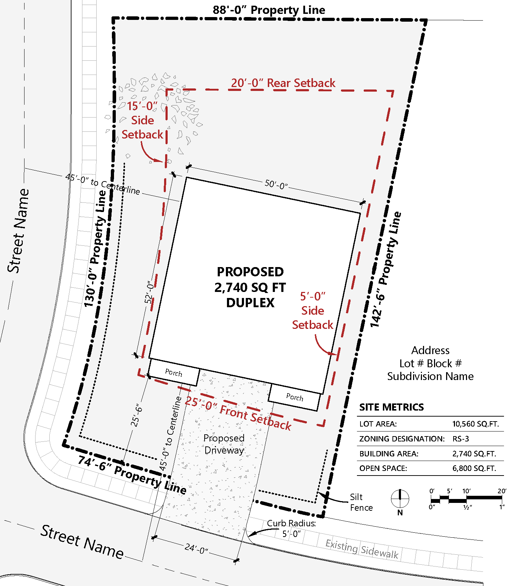

Elevation Requirements
Elevations may be required to illustrate the nature of the request. Elevations must show views of all building walls and include dimensions of all walls, roofline, and any architectural feature(s) that extend above the roofline. Please email a digital copy (PDF preferred) to planning@cityoftulsa.org. Elevations should be a minimum of 8.5”×11” and a maximum of 11”×17”, and should be scaled to show accurate dimensions.
Sample Elevation
